­­­­­

Youtube playlist Creator

Solution Design Document

Table of Contents

1. INTRODUCTION 3

1.1 Document overview 3

1.2 Objectives 3

2. Definitions & abbreviations 3

3. Solution Overview 4

3.1 List of packages 4

3.2 Solution diagram of the process 4

3.3 Solution description of the process 4

4. Process exceptions and checkpoints 5

4.1 Business exceptions 5

4.2 Application exceptions 5

5. Data storage 5

5.1 Data sources 5

6. Orchestrator and settings 6

6.1 Parameters 6

6.2 Assets 6

# INTRODUCTION

## Document overview

The Solution Design Document describes the design and key features of an automated business process. In an early stage of automation, it documents the high-level solution design. In this context, it is not necessary for all chapters to be updated. Subsequently, all chapters must be filled with detailed design information once the automated process moves into the testing phase.

## Objectives

The finalized document shall:

* Provide a high-level overview of the automated business process using UiPath technology.
* Describe the objects necessary for processing each business case.
* List and describe the technical requirements for each object used.
* List inputs and outputs of each part of the process.
* Outline the unique points and peculiarities of the solution.
* Mention potential risks regarding source data and results.

For every change, the automated process undergoes, this document must be updated too.

# Definitions & abbreviations

Add here any stakeholders that are involved in the process:

|  |  |  |
| --- | --- | --- |
| # | Term/Abbreviation | Definition/Description |
| 1 | Element | A robot consists of several building blocks. These can be states, transition lanes or functions. A member of this group is called an Element. |
| 2 | Orchestrator | UiPath Orchestrator, part of the UiPath RPA suite, is used to manage releases, schedules, queues, assets, licensing, users, bots – a central management hub. |
| 3 | Package | The output of compiling a project, which is published to UiPath Orchestrator. |

# Solution Overview

## List of packages

The process can be divided into x parts. It comprises y main processes:

|  |  |  |
| --- | --- | --- |
| # | Package Name | Description |
| 1 | RoboticEnterpriseFramework | Verifies if somebody is already logged into YouTube and if it is, signs out from YouTube and signs in with the given credentials, otherwise it just signs in. If the login fails, the application stops and an error message will be shown. If the login is successful, it searches for the given song names on YouTube and adds them in the corresponding playlist names if they exist and otherwise it creates the new playlist and adds the corresponding song in it. If the given songs and playlist names are incomplete, they won’t be added and an error message will be shown in the end with the incomplete data. |

## Solution diagram of the process

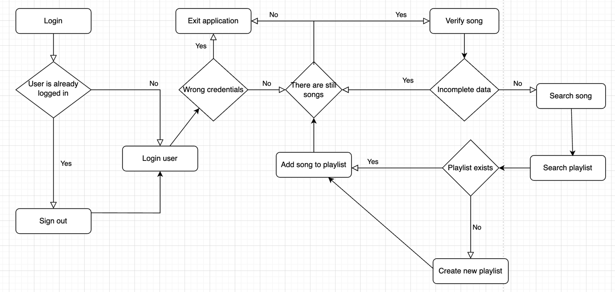

## Solution description of the process

|  |  |
| --- | --- |
| State | Description |
| Initialization | * Reads the data from the config file. * Kills all existing processes of Chrome and Excel. * Opens the Chrome browser and logins into YouTube. * It retrieves all information from the assets |
| Get Transaction Data | * Initializes playlist data from the Excel file if not already initialized. * Retrieves the first element. * Moves to the next element. |
| Process Transaction | * Processes one transaction at a time. * Searches for song in the existing playlists and adds it to the corresponding playlist. * If the given data is incomplete, the song won’t be added. * If the playlist doesn’t already exist, it creates a new playlist. |
| End Process | * Error message will be shown if data was incomplete. * Closes the application. |

# Process exceptions and checkpoints

## Business exceptions

|  |  |  |  |
| --- | --- | --- | --- |
| Step no. | Exception name | Workflow | Package |
|  | IncorrectEmailBE | LoginIntoYouTube | RoboticEnterpriseFramework |
|  | IncorrectPasswordBE | LoginIntoYouTube | RoboticEnterpriseFramework |
|  | NullPlaylistOrSongNameBE | Process | RoboticEnterpriseFramework |

## Application exceptions

|  |  |  |  |
| --- | --- | --- | --- |
| Step no. | Exception name | Workflow | Package |
|  | YouTubeIsDownSE | LoginIntoYouTube | RoboticEnterpriseFramework |

# Data storage

## Data sources

|  |  |  |
| --- | --- | --- |
| Resource | Location | Description |
| Configuration file | RoboticEnterpriseFramework\Data\Config.xlsx | The file where the application’s settings are located: YouTubeLink, RetryNumberYoutubeDown, LoginDelay and Business Exception and System Exception errors |
| Songs file | RoboticEnterpriseFramework\Input\Songs.xlsx | The file where the song names, playlist names and their privacy are located. |

# Orchestrator and settings

## Parameters

|  |  |  |  |
| --- | --- | --- | --- |
| Name | Direction | Type | Description |
| - | - | - | - |

## Assets

|  |  |  |
| --- | --- | --- |
| Asset Name | Type | Resource |
| botCredentials | Credential | Email and password inputs |